N-K-1 FGREORDER - Emailing Reorder Alert Emails for Finished Goods

The N-K-1 FGREORDER parameter is used to automatically create email alerts for finished goods items that fall below their reorder level. When posting a bill of lading, the software calculates the items available quantity to compare its reorder level and any item that is below this level will automatically create email to clients and/or to employees. The finished goods item must be set up as a reorder advice item, emails contacts must be created for customers and/or email contacts must be created for employees. Your company will save much more time by having the EMAIL automatically import the contacts to the SEND TO section of the email. Finally the program R-BOLPost must be assigned specific customer contacts and/or employee contacts.

Logical Value = YES to invoke this logic.   
Character Value = ReOrder Point

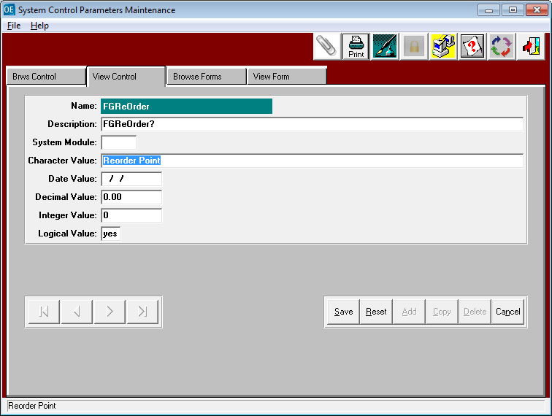

N-K-1 FGREORDER - Finished Goods File Maintenance

Only finished goods defined properly will generate email alerts. The item must be defined as a stocked item and he reorder policy radio button must be set to Reorder Point. The item may be manufactured or purchased whereby jobs and purchase orders will increase the on order quantity. Finished goods receipts will simultaneously increase the on hand quantity and decrease the on order quantity. Adding customer orders will increase the quantity allocated or reserved. When shipping inventory via the bill of lading, the program simultaneously decreases the on hand and allocated quantities. The quantity available to sell to new customers is calculated a on hand plus on order less allocated. When the quantity available is below the reorder level, the item must be replenished and the bill of lading posting program will automatically generate an email.

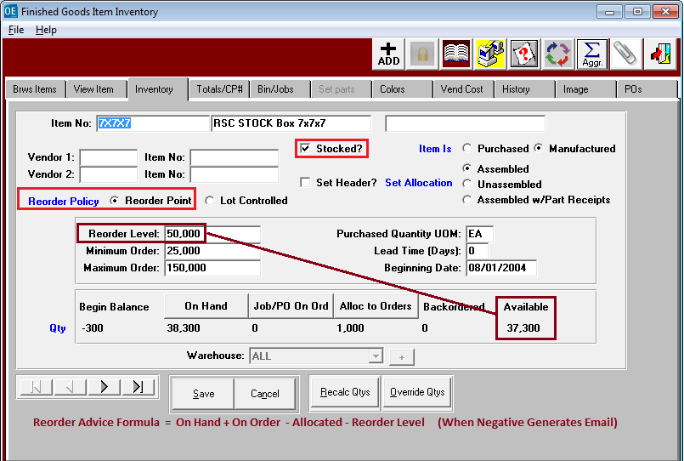

N-K-1 FGREORDER – Customer Phone Icon

Each contact can be setup for automatic emailing by clicking the E-MAIL NOTIFICATION toggle box.  
Once this is checked, then the business forms or reports can be checked that this person should receive.  
For example, below the program to post bill of lading is checked with the word YES. When posting a bill of lading, the software will generate an email alert and place the contacts on the SEND TO section of the email. Please note, this does not require the name to be setup in anyone’s Address Book in Microsoft Outlook. Click A-F-1 to access the customer file. Find the customer and click the Phone Icon to define all the contacts for this customer. You must enter the email address and check the email notification box. To email reorder advise alerts to this contact, you must check the program R-BOLPst to YES.  
Multiple contacts can receive the alert by repeating this process.

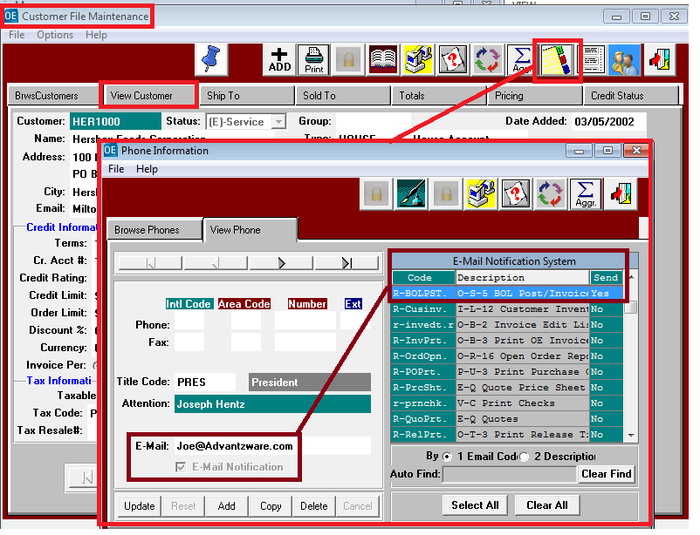

N-K-1 FGREORDER – Customer Employee Contacts

Employees can be setup by customer and/or for the manufacturing plant for automatic emailing by clicking the E-MAIL NOTIFICATION toggle box. Your box plant is defined in the customer file and will have a status of X for in house. Setting up employees for the box plant customer will allow a specific employee such a warehouse manager to receive all emails for all customers. However, to email specific customer service reps for specific customers, that employee must be defined by customer in the Employee Icon. To email reorder advice alerts to this employee, you must check the program R-BOLPst to YES. Multiple employees can receive the alert by repeating this process. As an alternative, you can simply add employees to the customer contacts Icon.

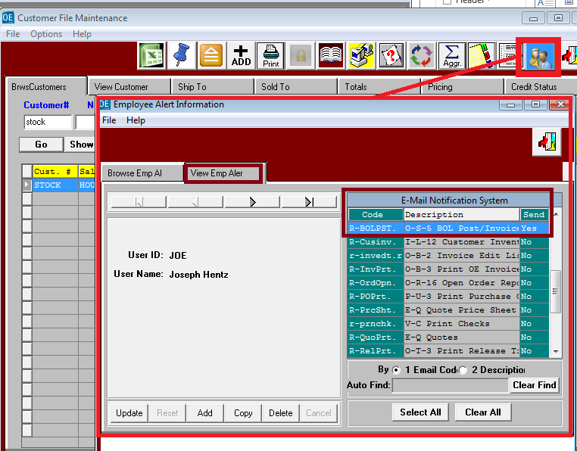

N-K-1 FGREORDER – ECODES

Each contact still must be setup in the customer file prior to using the Ecodes file. The Ecode files is an alternative method to setting up contacts for emailing. This provides the ability to quickly define many companies at one time, whereas the Customer is one Customer and one contact at a time. Each contact must still be defined in the Customer file with a title code and email address. At the top of the Main Menu, click the Codes button, then click the Email Codes Menu Option.

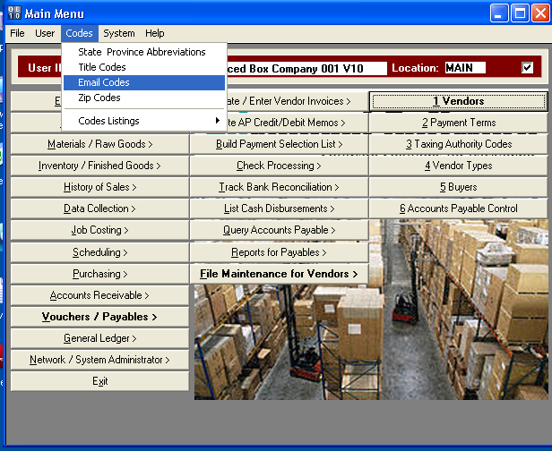

N-K-1 FGREORDER – ECODES

Find the program names R-BOLPst by typing the name in the AutoFind box at the Bottom. You can add, delete and view customer contact and employee contacts for the bill of lading post program to automatically send an email alert when inventory is below the reorder level.

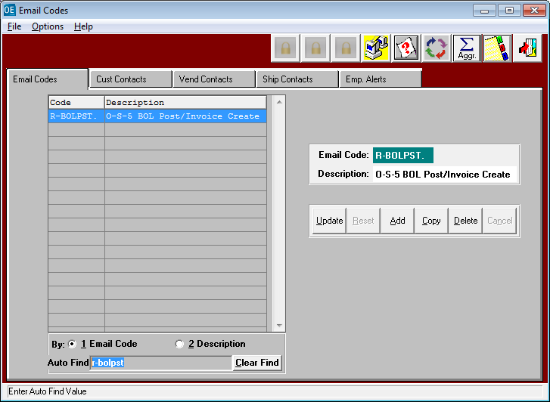

N-K-1 FGREORDER – ECODES for Customer Contacts

Customer Contacts can be defined in the Ecodes menu. The radio button and AutoFind Box allow you to find a specific customer by customer code, name, attention name or title. The TOP of the screen shows the contacts that will receive email alerts. The bottom on the screen shows all the contacts for all the customers defined in the customer file. The bottom screen is to select specific contacts and the ADD button transfers the contacts from the Bottom Screen to the TOP Section of the screen.

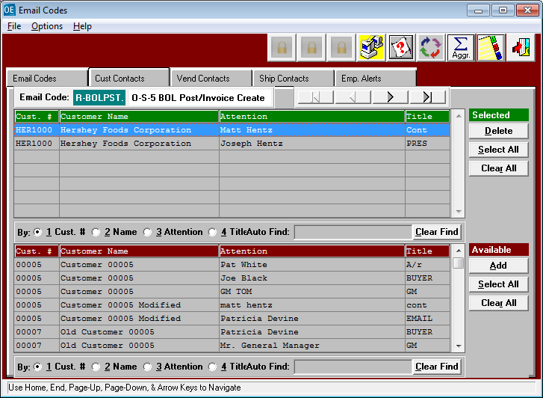

N-K-1 FGREORDER – ECODES for Employees

Employees defined as Contacts can be defined in the Ecodes menu. The radio button and AutoFind Box allow you to find a specific customer by customer code, name, attention name or title. The TOP of the screen shows the contacts that will receive email alerts. The bottom on the screen shows all the contacts for all the customers defined in the customer file. The bottom screen is used to select specific contacts. The ADD button transfers contacts from the Bottom Screen to the TOP Section of the screen.

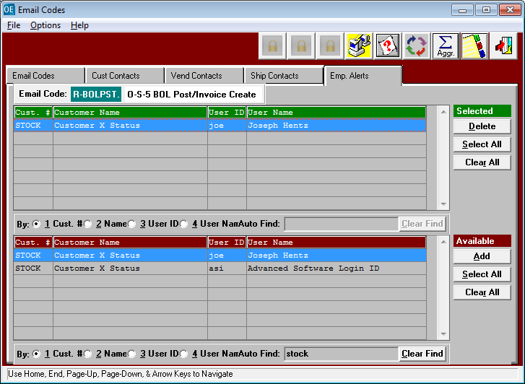

N-K-1 FGREORDER – Bill of Lading Posting

When the Finished Good Item is Posted, the program automatically creates an email.

